Ukraine Extension Scheme

This guide is for people looking to apply under the Ukraine Extension Scheme.

You are eligible to apply for the Ukraine Extension Scheme if:

- You are in the UK, and
- You are a Ukrainian citizen or applying with a family member who is a Ukrainian citizen, and
- You had leave to enter or leave to remain in the UK:
  - on the 18th March 2022, or
  - immediately before the 1st January 2022 and it has now expired
- If you were born after the 1st January 2022, you are in the UK, and your parents meet the requirements above, you can also apply to the Ukraine Extension Scheme.

Under the Ukraine Extension Scheme, you will be granted 3 years leave to remain and will be able to work, study and access benefits. To find out more about the scheme and to apply, go to:

https://www.gov.uk/guidance/apply-to-stay-in-the-uk-under-the-ukraine-extension- scheme?utm_medium=email&utm_campaign=govuk-notifications-topic&utm_source=8ff413b2-0f19-4d0f-82e1-1409c6fb3620&utm_content=immediately#apply

The application form is available in English, Ukrainian and Russian.

We have created this handy guide to help you complete the application form. The people in the application form are fictional.

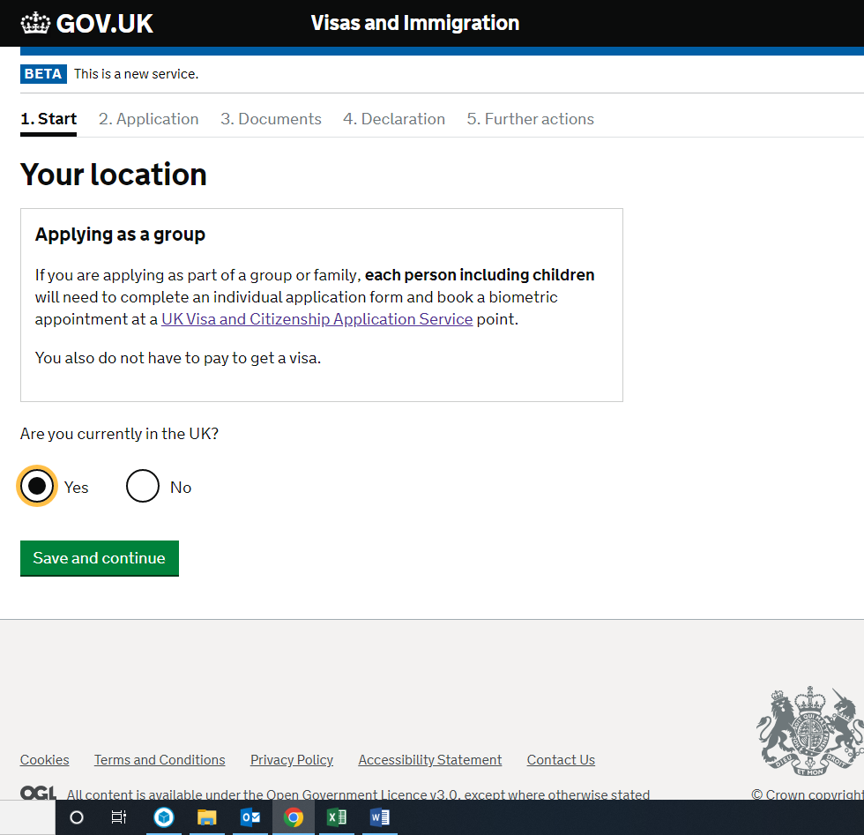

If you are not in the UK, you will not be able to apply under this scheme. You may be eligible to apply for the Ukraine Sponsorship Scheme (Homes for Ukraine) or Ukraine Family Scheme instead. For more information, please refer to the relevant guides on our website.

You will then be asked whether you have any outstanding applications with the Home Office.

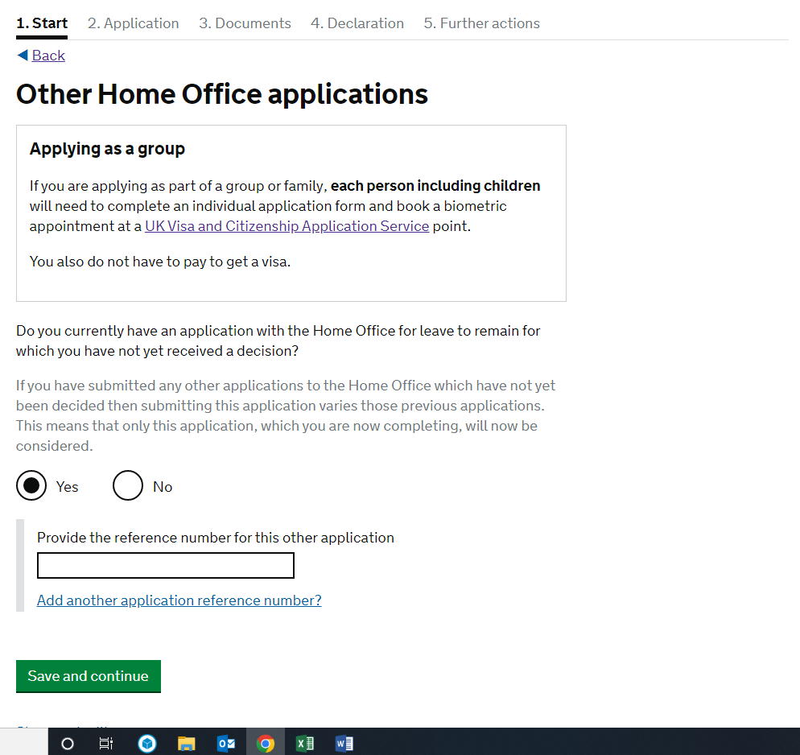

If you do have any outstanding applications with the Home Office, including an asylum claim, you will need to enter your Home Office reference number in the text box provided. You can find your Home Office reference number at the top of any letters or emails from the Home Office.

Next, you will be asked to select the type of application you are making. It is important that you select the correct one – Ukraine Extension Scheme.
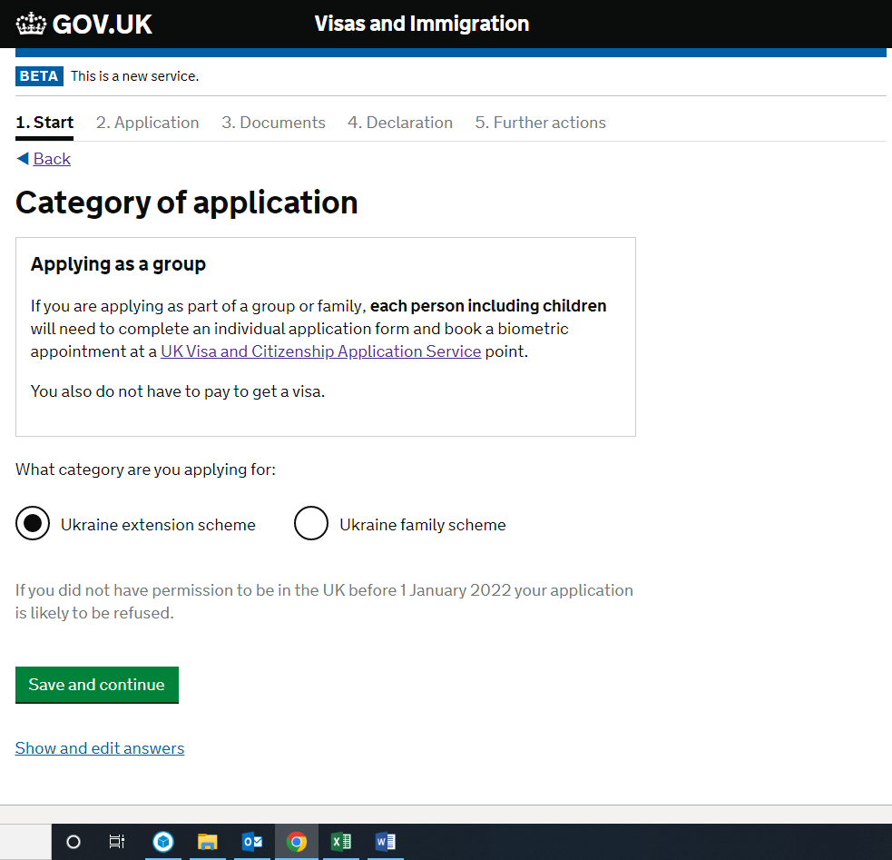

Please note that if you had permission to be in the UK on the 18th March 2022, your application should be accepted.

You will then be asked to register an email. This should be an email that you have regular and easy access to as it will be the Home Office’s main method of communication with you.

You will then be emailed a link to verify your email address. You will need to verify your email address before you can submit the application.

You will also need to confirm who the email address belongs to.

You do not need an immigration adviser in order to complete this application form. If you do have a UK based immigration adviser, we would suggest you seek advice from them before filling in the application form.

You will then be able to check your answers before continuing on to the next part of the application.

Once you are happy with your answers, you can press continue. You will then be asked to enter your personal information.

If your patronymic is on your passport, you should enter this after your first name, ie Viktoriia Petrivna.

You will also need to enter any other names you are, or have ever been, known by:

If you have never been known by any other name, go to page 12. Otherwise, see below:

Once you have entered all your previous names, you will be able to proceed to the next section.

If you are filling in this form on behalf of someone else, you will now be asked to enter their contact details:

If you are the applicant, you will be asked if you are happy to be contacted on the email address provided. If not, you will be able to give further contact details.
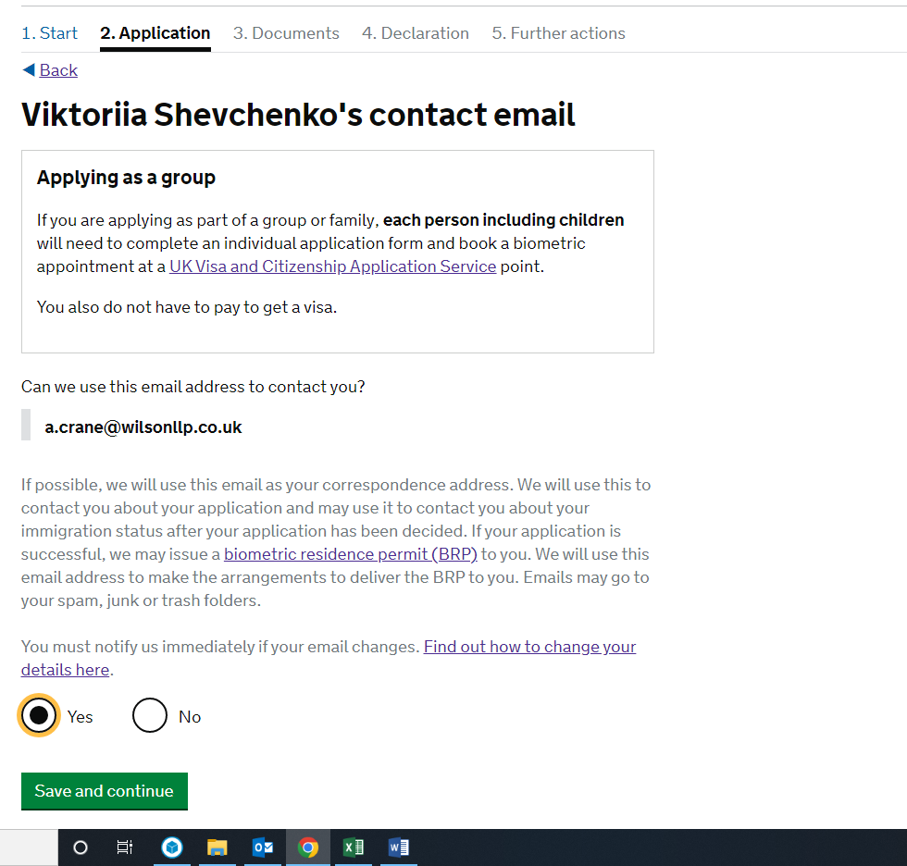

You will then be asked to provide a telephone number:

Next, you will be asked to provide a postal address. If possible, you should provide your current address. You can enter your postcode in the box provided and search for your address, or you can enter your address manually:

You will also need to enter the date that you first started living at that address.

If the postal address provided is not the same as the address where you live, you will be asked to provide your current address as well, along with the date you first started living there.

Once you have provided your postal address, you will need to provide all your previous addresses in the UK and abroad over the last 2 years, including the date you moved in and out. If it is a UK address, you will again be able to search for the property by entering the UK postcode. If not, you will have to enter the address manually:

To continue with the application form, you must enter a postcode. If your previous address did not have a postcode, you can enter ‘0000’ instead.

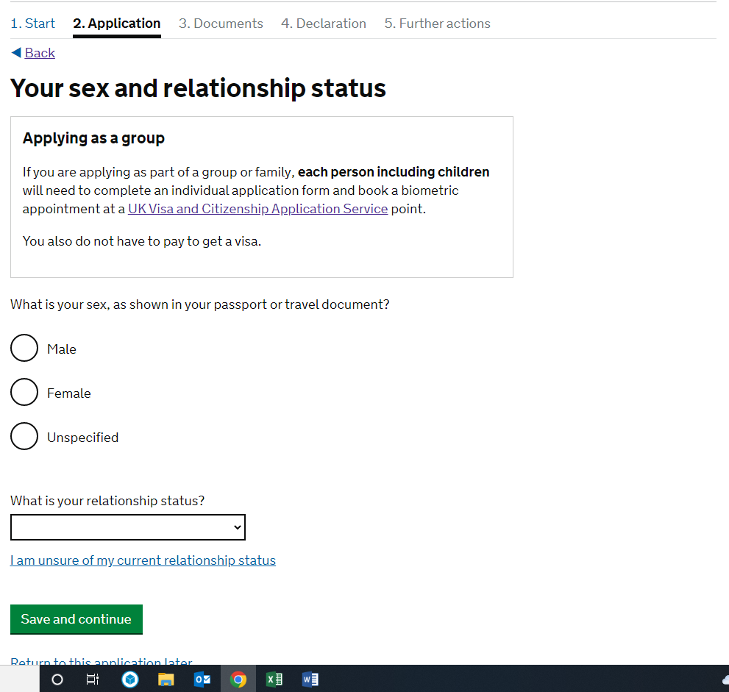

You will be able to choose from several options when describing your relationship status:

You will also need to provide details about your nationality, country and date of birth. You should use the information on your passport – for example, if your passport says that you were born in Ukraine, you should enter Ukraine rather than the specific town/city you were born in:

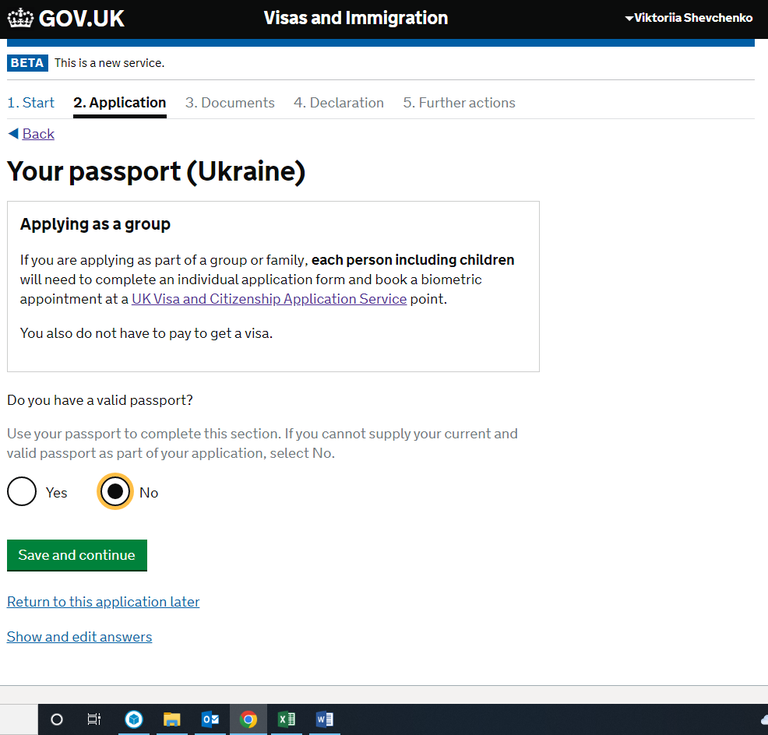

If you have a valid international passport, you will need to complete the details below. If not, go to page 22.

Once you have entered your passport details, press save and continue. Go to page 29.
If you cannot provide your passport, then you will need to explain why. This could be because you have lost it, you have never had a passport, or your passport is no longer valid and you are waiting to receive a new one.

You will be asked if you can provide a copy of your passport details instead:
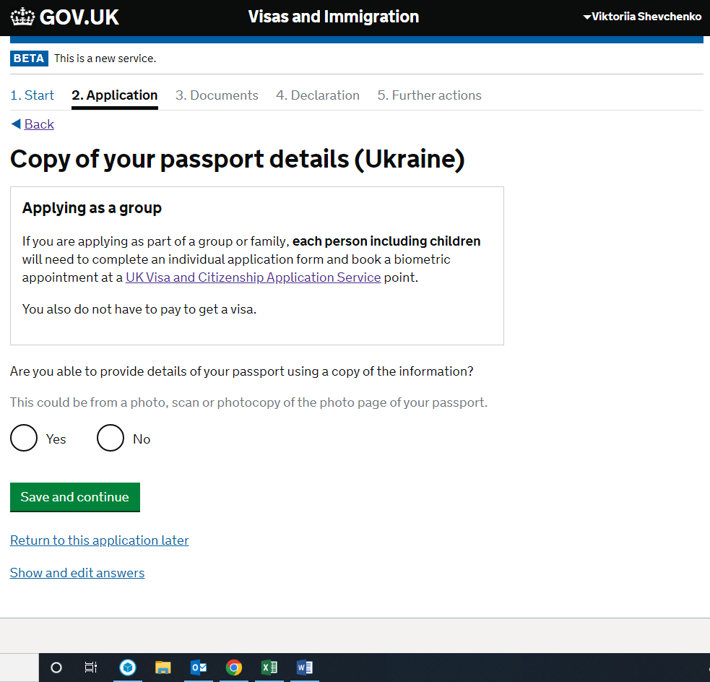

If the answer is yes, you will need to complete the form below, then go to page 29. Otherwise go to page 24:

If you cannot provide a copy of your passport details, you will be asked if you are able to provide details of an expired passport:

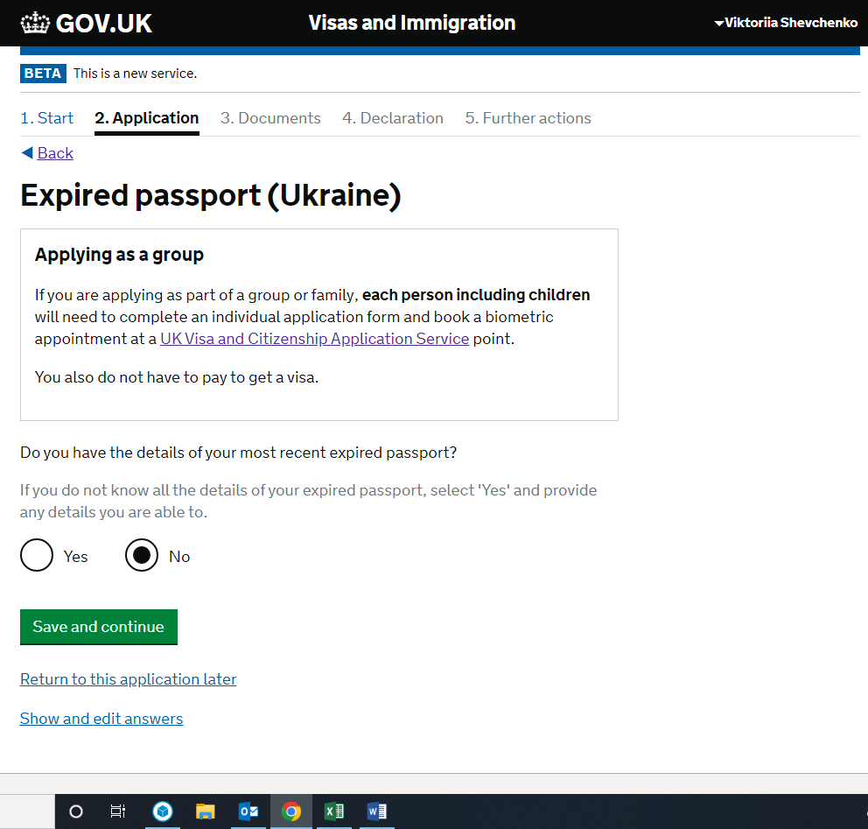
If you can provide these details, you will need to complete the page below, then go to page 29. If not, go to page 25:

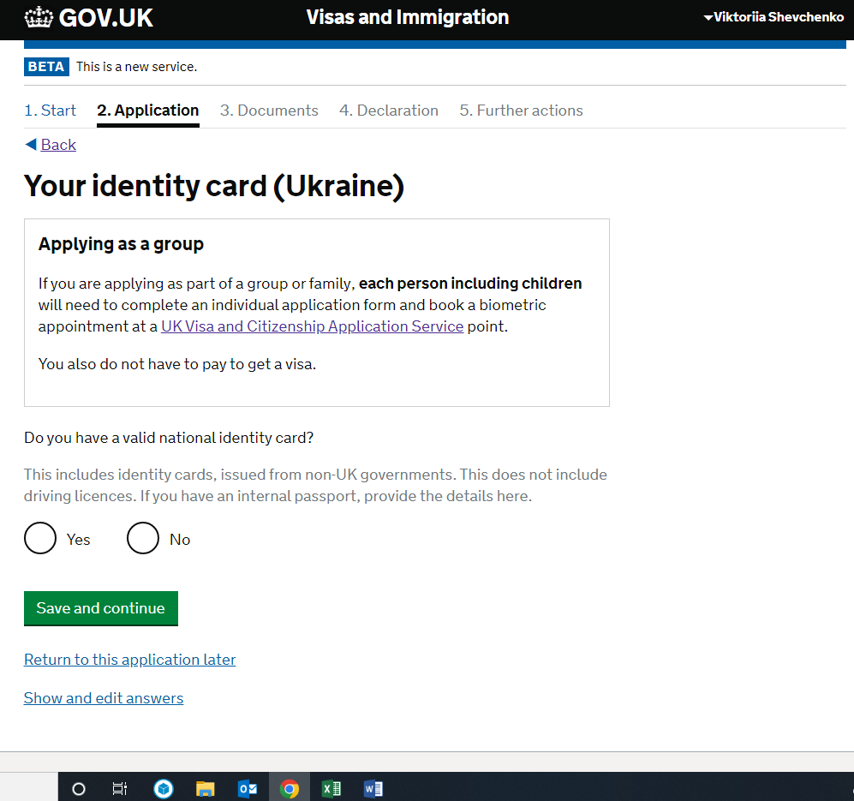

If you have a valid national identity card (or internal passport), you will need to enter these details as below, then go to page 29. Otherwise, go to page 26:

If you do not have a valid national identity card (internal passport), you will be asked for details of your most recent expired national identity card (internal passport):

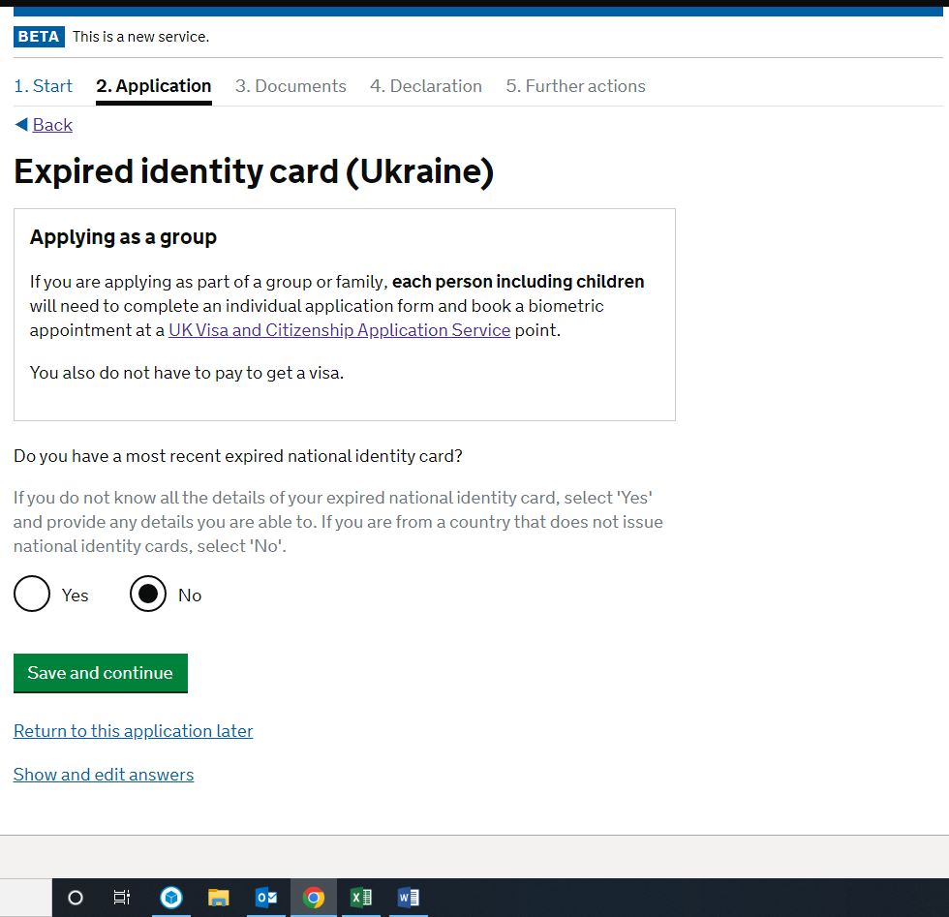

If you can provide these details, please see below, then go to page 29. If not, go to page 27.

If you do not have a passport or a national identity card, you will be asked to provide details of a travel document:

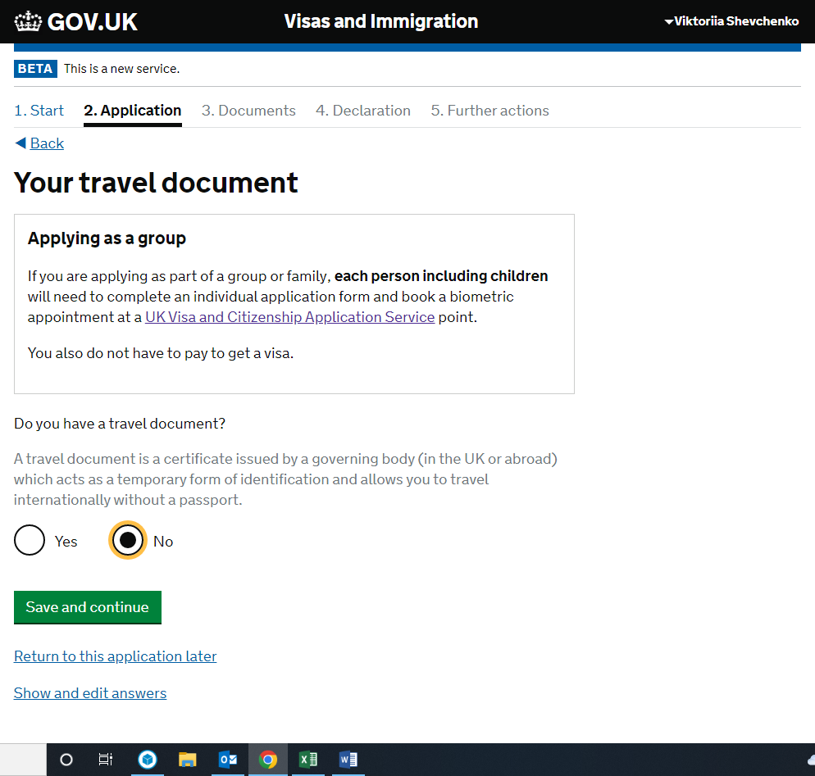

If you can provide these details, please see below, then go to page 29. Otherwise go to page 28.

If you cannot provide any of the requested information, you will need to explain why. You should also let the Home Office know if there is any other form of identification you can provide, and make sure that you submit this with your application.

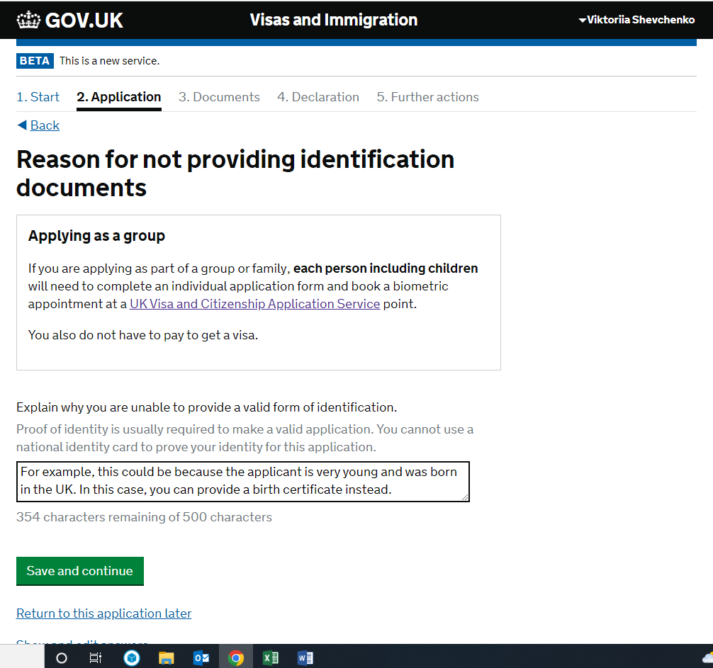

You will now be able to move to the next step.

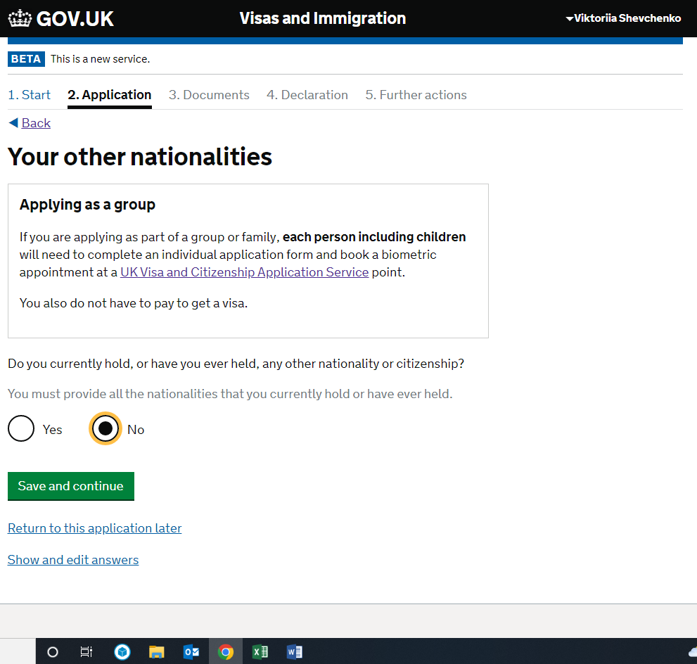

If you hold or have ever held any other nationality or citizenship, you will need to provide details of this here. If not, go to page 32.

You will also be asked if you have a valid passport for this country.

You will also need to enter the details of any national identity card you have for this country:

Once you have entered in the details of any other nationality or citizenship you hold, you can proceed to the next step. If you do not have any form of ID from this other country, that is fine and you will not be asked any further questions about this.

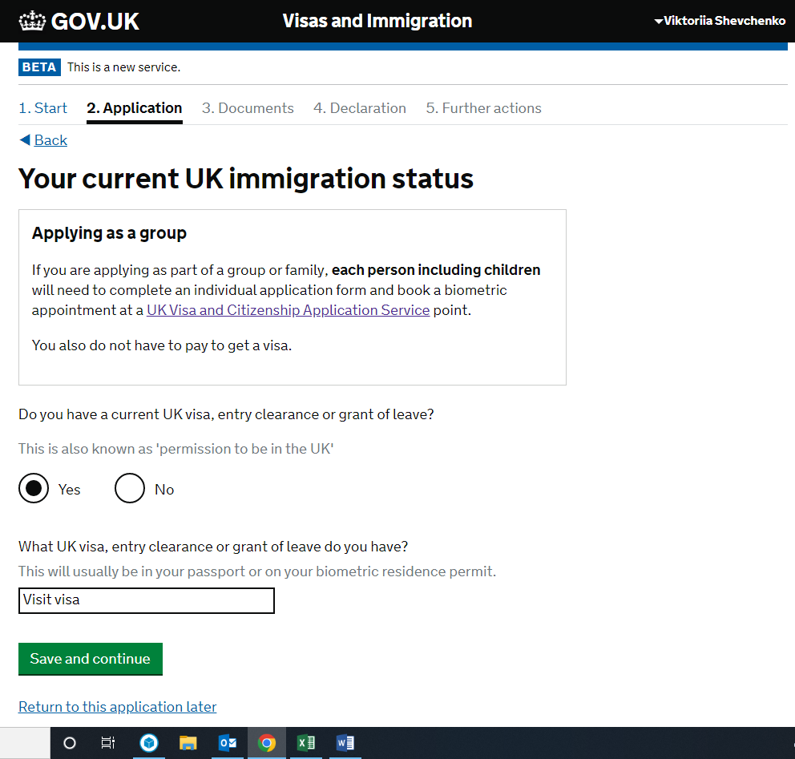
If you do not have a current UK visa, entry clearance or grant of leave, you will need to provide details of your most recent visa, entry clearance or grant of leave – go to page 33. Otherwise, see below, then go to page 34:

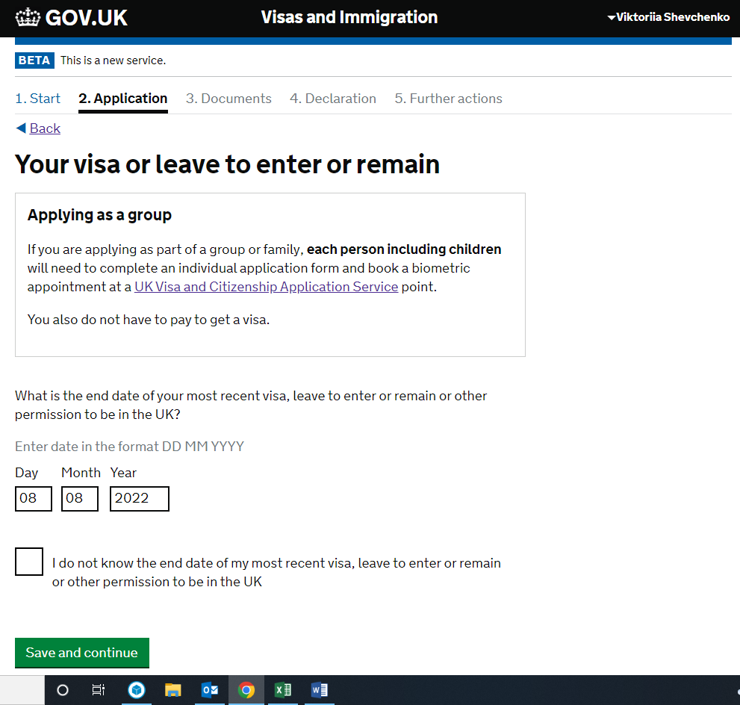
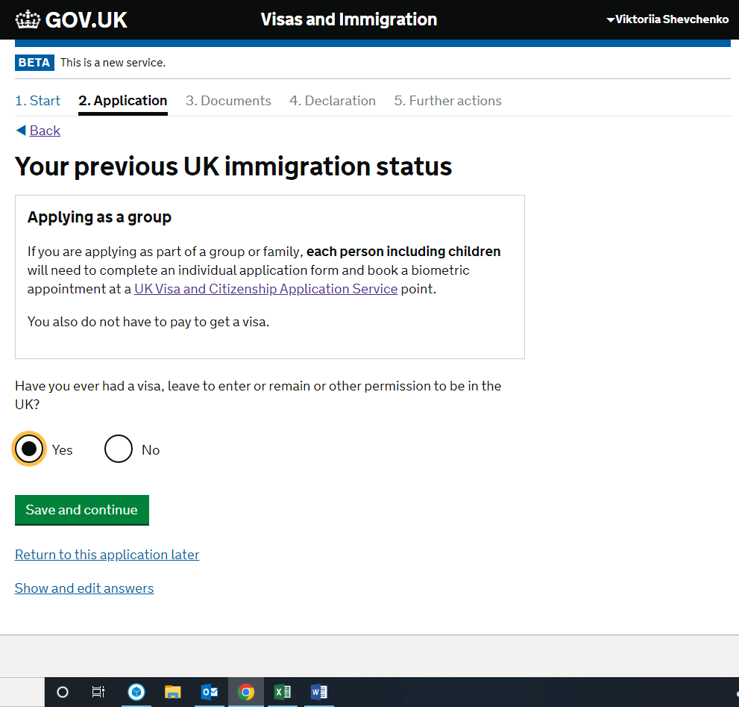
If you have never had a visa, leave to enter/remain or other permission to be in the UK, you are unlikely to be accepted under the Ukraine Extension Scheme and should seek further legal advice on this matter.

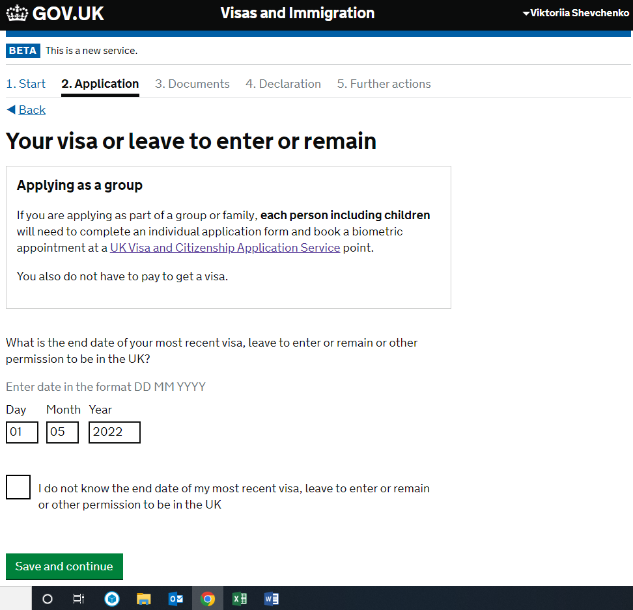

If you said that you had a partner, you will now be asked questions about your partner. If you do not have a partner, go to page 35:

You will first be asked whether you are living with your partner. You will then be given a series of textboxes depending on your answer to provide further information (see below). You should try to give as much information here as possible. If you do not know something, you should explain this rather than providing incorrect information.

You will next be asked about any other family members who are applying with you. For example, this might be a child, partner, sibling or parent. You will need to make sure that you submit an application form for each person. If you do not have any family members applying with you, go to page 36, otherwise see below:

If your family member does not have a passport, you can leave the final section blank. Once you have added all the family members applying with you, you can proceed to the next section.

If you have a National Insurance Number, you should enter it in the textbox provided. Otherwise, you will be asked if you are happy to be allocated one:

You will need a National Insurance Number to work and access benefits. You cannot continue with the application form if you do not consent to your information being shared with the Department of Work and Pensions.

Next you will be asked to provide details of any immigration issues you have had in the UK or any other country. It is vital that you answer all these questions honestly, even if you have previously broken immigration laws in the UK.

If the answer to this question is no, go to page 39. Otherwise, go to page 38:

Once you have entered in the details of all immigration issues you have had, you can proceed to the next section.

If the answer to this question is no, go to page 40. If the answer is yes, see below:
Pages 40 – 42 cover the security questions you will be asked. If the answer to any of these questions is yes, you should seek legal advice before proceeding.

If the answer to any of the above is yes, you will be asked to provide more information as on page 41. If the answer is no, go to page 42.

Once you have entered details of all convictions and offences, you can proceed to the next step.

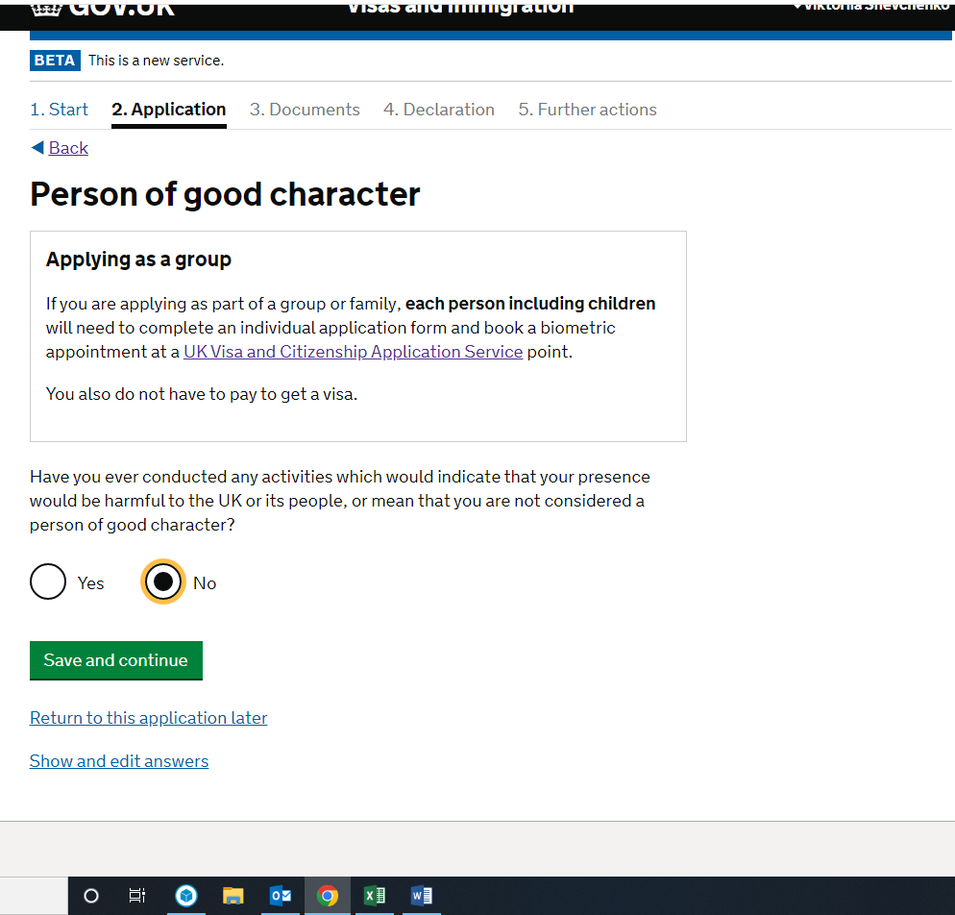

Once you press ‘Save and continue’, you will be given a chance to check your answers before submitting. You will then be able to submit your application and will be asked to book a biometric appointment using the Home Office’s UKVCAS website. You can download a copy of your answers at any time by logging onto your application form and selecting download pdf from the drop-down menu in the top right hand corner.

