Ukraine Family Scheme
Inside the UK

This guide is for people looking to apply under the Ukraine Family Scheme from inside the UK.

You are eligible to apply for the Ukraine Family Scheme if:

- You were living in Ukraine immediately before 1st January 2022, unless you are a child born after this date
- You are a Ukrainian citizen or the family member of a Ukrainian citizen who is applying with you under the scheme
- You have a family member in the UK who is one of the following:
  - A British citizen
  - A person with settled status in the UK
  - A person with refugee status or humanitarian protection in the UK
  - An EEA national in the UK with pre-settled status
- Your family member is:
  - either
    - Your partner
    - Your child
    - Your parent
    - Your grandparent
    - Your grandchild
    - Your sibling
    - Your aunt or uncle
    - Your cousin
    - Your niece or nephew
    - Your partner’s parent, grandparent or sibling
  - Or
    - The partner of a family member
    - The child of a family member
- You are over 18 or:
  - You are applying with one or both of your parents
  - You are joining one or both of your parents in the UK
  - You have written parental consent to join a family member in the UK

Under the Ukraine Family Scheme, you will be granted 3 years leave to remain and will be able to work, study and access benefits. To find out more about the scheme and to apply, go to:

https://www.gov.uk/guidance/apply-for-a-ukraine-family-scheme-visa#apply-from-inside-the-uk

The application form is available in English, Ukrainian and Russian.

We have created this handy guide to help you complete the application form. In this case, Viktoriia Shevchenko and her brother, Yurii Shevchenko, are applying to join her son, Oleksandr Shevchenko, in the UK. The people in this application form are fictional.

If you are not currently inside the UK, you should refer to our Ukraine Family Scheme: outside the UK guide.

If you have any outstanding Home Office applications, including an asylum claim, you should provide the reference number in the text box provided. You can find your Home Office reference number at the top of any Home Office correspondence.

You will next need to confirm which scheme you are applying for.

You will need to confirm that you were living in Ukraine on 31st December 2021. If you were not living in Ukraine on this date, you should seek legal advice.

You will then be asked to confirm what status your UK based family member has in the UK. If you are unsure, you should ask your family member.

You will then be asked to supply your contact details.

You will be sent a verification link to your email. You will not be able to submit your application without first completing the verification step.

You will need to confirm whose email address you have provided:

If you are completing this application on behalf of someone else, you will be given an opportunity later in the application to provide their contact details as well.

You will be asked if you have an immigration adviser in the UK:

You do no not need an immigration adviser to complete this application. If you do have an immigration adviser, you will be asked to provide their details. You should speak to your immigration adviser first before completing this section.

The form will then ask for the details of your UK based family member:

You will also need to confirm how you are related to your UK based family member:

The application form will then ask if you, or an immediate family member applying with you, is a Ukrainian citizen:

If the answer to this question is no, you will not be able to continue with the application form and you should seek legal advice.

You will then be asked to provide more information about your UK based family member:

If you do not know your family member’s passport details, that is okay. You will need to supply another form of ID for this person and evidence of their status in the UK. For example, this might be a birth certificate, certificate of naturalisation as a British citizen, or a letter from the Home Office granting them refugee status.

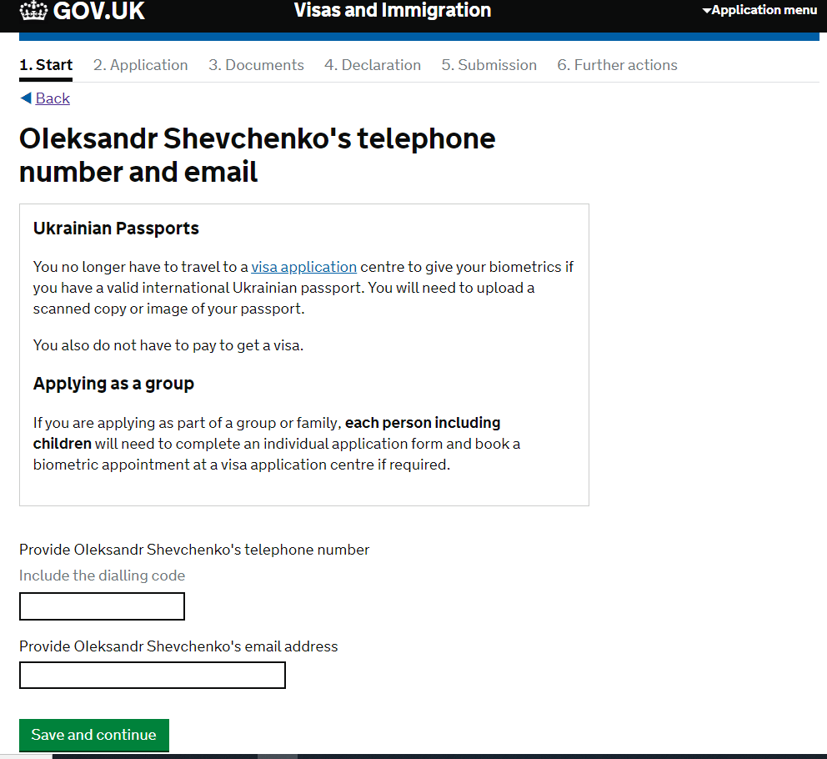

You will then be given an opportunity to check your answers before you move on to the next stage of the application:

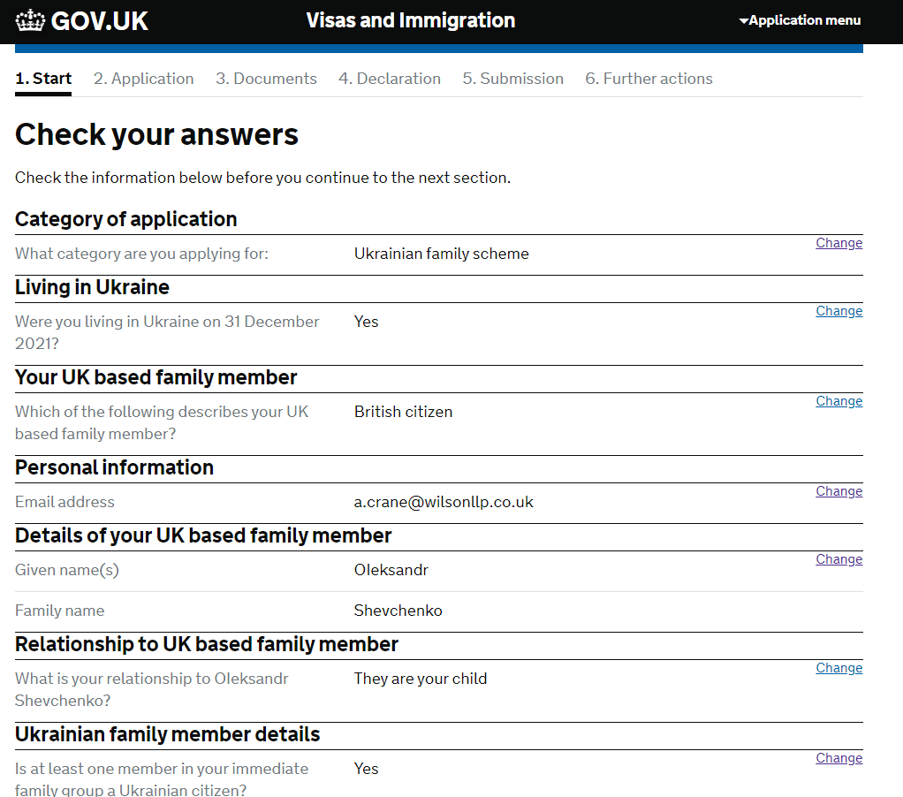

You should enter your name as it is written on your passport/ID document. If your patronymic is on your passport, you should enter it under ‘Given name(s)’, for example: Viktoriia Petrivna.

If you have ever been known by any other name, you will need to enter this as below. Otherwise, go to page 13.

Once you have entered all previous names, you will be able to move to the next step.

If you are filling the form in on behalf of someone else, you will be asked to supply the applicant’s email address:

If you are filling in the application on your own behalf, you will be asked to confirm the best email address for the Home Office to contact you on:

You will then need to provide your telephone number:

Next, you will need to provide a postal address.

You will also need to enter the date that you first started living at that address.

If the postal address provided is not the same as the address where you live, you will be asked to provide your current address as well, along with the date you first started living there.

Once you have provided your postal address, you will need to provide all your previous addresses in the UK and abroad over the last 2 years, including the date you moved in and out. If it is a UK address, you will again be able to search for the property by entering the UK postcode. If not, you will have to enter the address manually:

To continue with the application form, you must enter a postcode. If your previous address did not have a postcode, you can enter ‘0000’ instead.

Once you have entered all your previous addresses, you can move to the next stage:
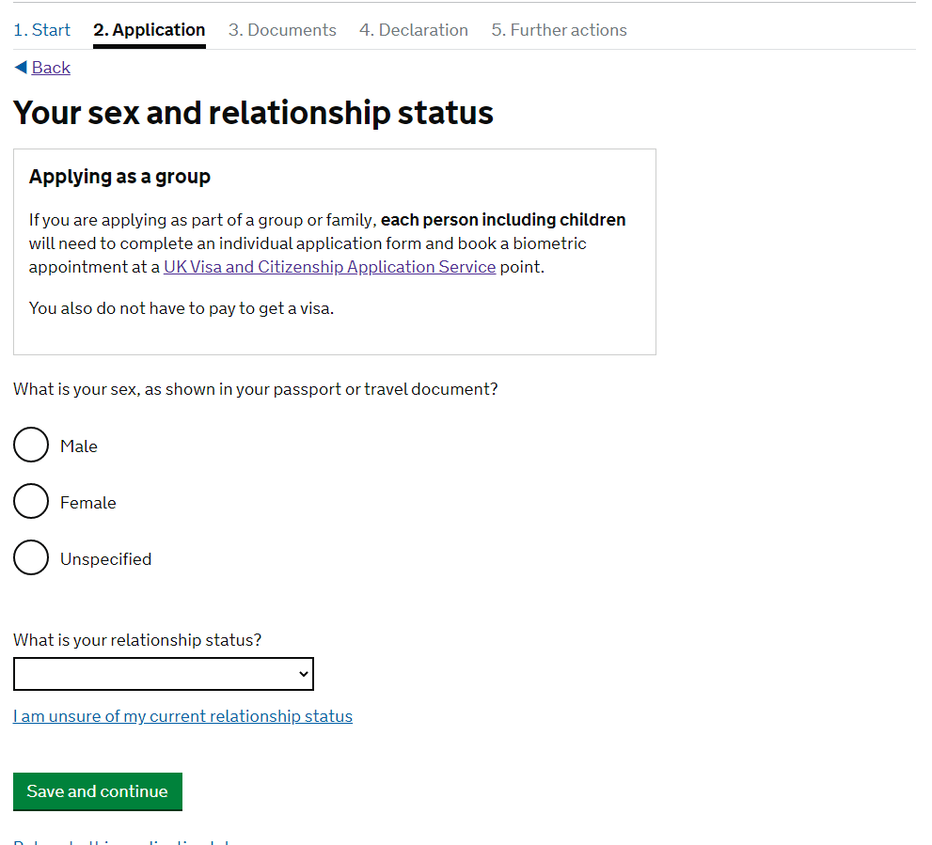

You will be able to choose from several options when describing your relationship status:

You will also need to provide details about your nationality, country and date of birth. You should use the information on your passport – for example, if your passport says that you were born in Ukraine, you should enter Ukraine rather than the specific town/city you were born in:

If you have a valid international passport, you will need to complete the details below. If not, go to page 22.

Once you have entered your passport details, press save and continue. Go to page 28.
If you cannot provide your passport, then you will need to explain why. This could be because you have lost it, you have never had a passport, or your passport is no longer valid and you are waiting to receive a new one.

You will be asked if you can provide a copy of your passport details instead:

If the answer is yes, you will need to complete the form below, then go to page 28:

If you cannot provide a copy of your passport details, you will be asked if you are able to provide details of an expired passport:

If you can provide these details, you will need to complete the form below, then go to page 28.

If you are not able to provide these details, see below:

If you have a valid national identity card (or internal passport), you will need to enter these details as below, then go to page 28.

If you do not have a valid national identity card (internal passport), you will be asked for details of your most recent expired national identity card (internal passport):

If you can provide these details, please see below, then go to page 28.

If you do not have a passport or a national identity card, you will be asked to provide details of a travel document:

If you can provide these details, please see below, then go to page 28.

If you cannot provide any of the requested information, you will need to explain why. You should also let the Home Office know if there is any other form of identification you can provide, and make sure that you submit this with your application.

You will now be able to move to the next step.

If you hold or have ever held any other nationality or citizenship, you will need to provide details of this here. If not, go to page 31.

You will also be asked if you have a valid passport for this country.

You will also need to enter the details of any national identity card you have for this country:

Once you have entered in the details of any other nationality or citizenship you hold, you can proceed to the next step. If you do not have any form of ID from this other country, that is fine and you will not be asked any further questions about this.

If you do not have a current UK visa, entry clearance or grant of leave, you will need to provide details of your most recent visa, entry clearance or grant of leave – go to page 32. Otherwise, see below, then go to page 34:

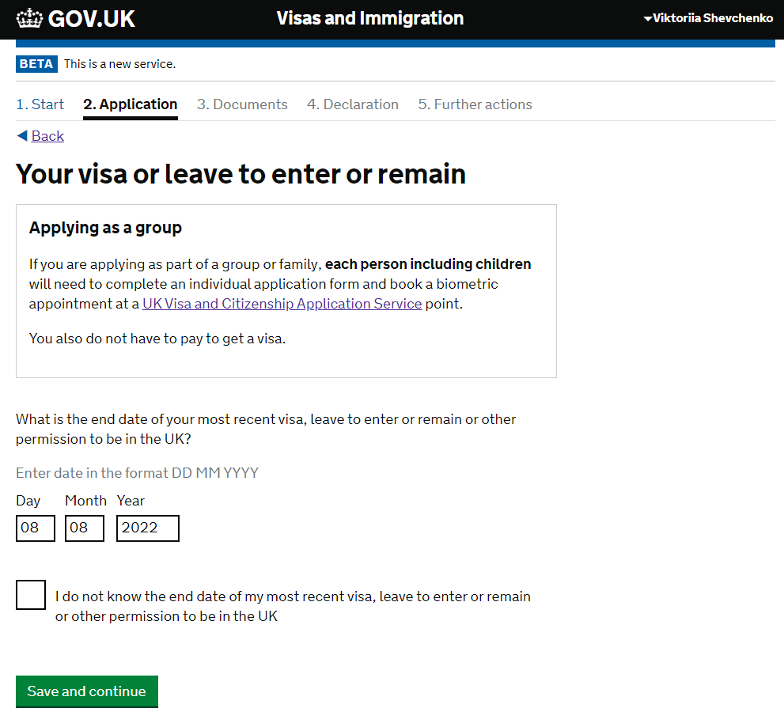

If the answer to this question is yes, see below, then go to page 34. If the answer to this question is no, go to page 33

If you have never had any leave to enter or remain in the UK, you will be asked to explain how you entered the UK. You should provide as much information as possible, even if entered illegally.

If you said that you had a partner, you will now be asked questions about your partner. If you do not have a partner, go to page 35:

You will first be asked whether you are living with your partner. You will then be given a series of textboxes depending on your answer to provide further information (see below). You should try to give as much information here as possible. If you do not know something, you should explain this rather than providing incorrect information.

You will next be asked about any other family members who are applying with you. For example, this might be a child, partner, sibling or parent. You will need to make sure that you submit an application form for each person. If you do not have any family members applying with you, go to page 36, otherwise see below:

If your family member does not have a passport, you can leave the final section blank. Once you have added all the family members applying with you, you can proceed to the next section.

If you have a National Insurance Number, you should enter it in the textbox provided. Otherwise, you will be asked if you are happy to be allocated one:

You will need a National Insurance Number to work and access benefits. You cannot continue with the application form if you do not consent to your information being shared with the Department of Work and Pensions.

Next you will be asked to provide details of any immigration issues you have had in the UK or any other country. It is vital that you answer all these questions honestly, even if you have previously broken immigration laws in the UK.

If the answer to this question is yes, see below, otherwise go to page 39:

Once you have entered in the details of all immigration issues you have had, you can proceed to the next section.
You will be then asked a series of security questions. If the answer to any of these questions is yes, you should seek legal advice before proceeding.

Finally, you will be asked about your employment history. If you have ever worked in any of the jobs listed below, you may want to seek legal advice before submitting your application:

Once you have completed the application form, you will be given a chance to check your answers. You will then need to confirm that you can supply any mandatory documents (ie your passport) before you can proceed to submit your application. You will be able to download a copy of your completed application form at this point.

You will then be redirected to a third party website where you can upload your documents and book your biometric appointment if necessary.

You will be able to download a copy of your completed application form at any time by logging back into your application. You can also download a copy of your application form at any time before you submit by selecting ‘download PDF’ from the drop-down menu in the top right hand corner

